**Week#10**

**Dynamic Routing**

**Learning objectives:**

* Appreciate Dynamic Routing Protocol ( RIP)

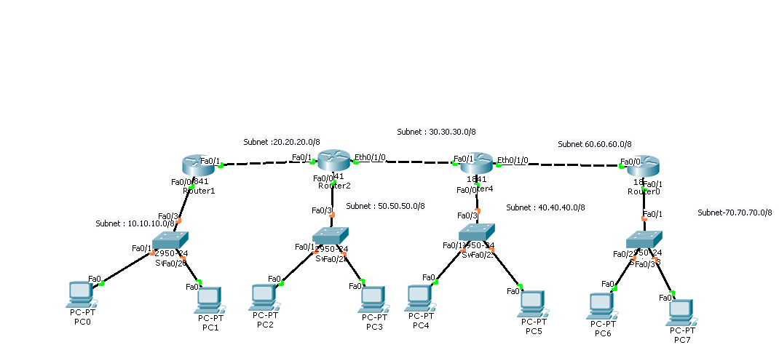

1. **Dynamic Routing Protocol ( RIP)**

|  |  |  |  |  |
| --- | --- | --- | --- | --- |
|  | **Action** | | **Observation** | **Reason** |
| * 1. **In real time mode** | | | | |
| 1 | Use the topology as shown above.  Configure the IP addresses | |  |  |
| 2 | Configure the routing tables of all the routers.  **Note , this time you need to select RIP mode** | |  |  |
|  | * **Enter the subnet ID of only the subnets attached to each interface of the router** * **Enter only directly connected networks** * **No need to enter IP address of the next hop** | |  |  |
| 4 | Test the network | | **Get the successful communication** |  |
| 5 | Use inspection tool ( lens like button in the right ) to click on a router and select Routing table | | **Routing table of every router** | **How many subnets entries are created in each router?** |
|  |  | |  |  |
|  |  | |  |  |
|  | **Action** | | **Observation** | **Reason** |
| * 1. **In Simulation mode** | | | | |
| 1 | Click power cycle devices |  | |  |
| 2 | Click auto-capture and play |  | |  |
| 3 | Use inspection tool ( lens like button in the right ) to click on a router and select Routing table  Give address of router one by one and activate RIP | Keep the table active and wait | |  |
|  |  | Initially routing table is blank. | |  |
|  |  | Slowly routing table is getting updated. | |  |